Jake Howard

Saviour Backup System

Saviour Backup System

User Manual

Contents

Installation Instructions 1

Backup Process 1

Adding a Backup Record 1

Backup your drive 2

Backup Rules 2

Modify Rules 2

View backup progress 2

General Instructions 2

Closing the program 2

Saviour Backup System is a simple, lightweight and easy to use backup system for portable USB drives. Using this software, you can back up your portable devices to your computer, so if they get damaged, you can quickly restore the data onto another drive so that down time is kept to a minimum.

### Installation Instructions

Installing software is very simple. Inside the ZIP file will a ‘setup.exe’ file, this will install the software automatically for you in the correct location, and download all necessary files. The software will also attempt to install any other pieces of software that Saviour Backup System needs, all of which are official installs. Once the install is complete, the installed will start Saviour Backup System, and the main window will be displayed.

# Backup Process

## Adding a Backup Record

In order for the software to back up your drive, it must have a backup rule created for it.

1. Select the ‘Add Backup Rule’ Button from the ‘Backup and Restore’ Menu
2. Fill in the details in the new window. Hover over the input boxes to find out information about what needs to go in there
3. Once you have filled in the information, click ‘Create’. If there are any problems with your inputs, error messages will now appear
4. If there are no errors, then a drive record will be created.
5. The window will now close, and below your drives information will appear the record information.

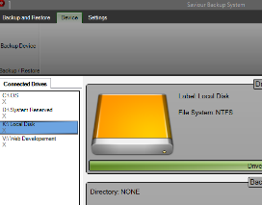

## Backup your drive

Obviously for a backup system to function properly, it needs to be able to back up drives. So here’s how to do it:

1. With the drive you wish to backup selected, click ‘Backup Drive’ from the devices tab.
2. Your drive will now begin to backup.
3. If you selected compression for this drive, then compression will begin once backup is complete, be warned this can take a long time for large drives.

# Backup Rules

## Modify Rules

If a rule needs to be changed, for one reason or another. Then this is how it’s done:

1. Select the ‘View All Rules’ option from the ‘Backup and Restore’ tab.
2. 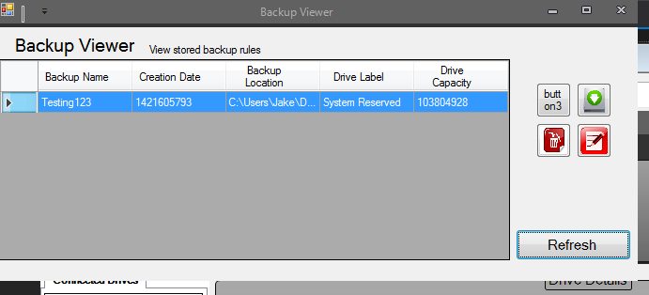You can now see a list of all the records that are stored on your computer.
3. With the required record selected, you can do various different things:
   1. Edit a record by clicking the notepad button
   2. Delete a record by clicking the trash button
   3. Add a new record by clicking the hard drive button
4. To refresh the record view, press the refresh button

## View backup progress

So that you can keep track of the different backup processes, you can use the ‘Current Transfers’ window to view the currently running backups.

1. From the ‘Backup and Restore’ tab on the main window, select ‘Current Transfers’.
2. Any transfers that are ongiong will appear here with the current progress
3. To clear the list, press ‘Clear’. Please note this will stop all ongiong transfers, a warning wil reitterate this.

# General Instructions

## Closing the program

Closing the program is something that everyone is going to need to do eventually, but closing it completely is a bit more confusing.

1. 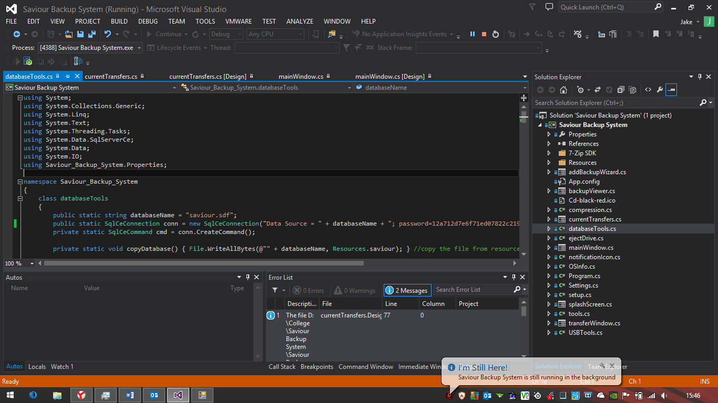To close the main window, press the ‘X’ in the top right corner. A dialog will then display on the task bar, reminding that the software is still running, which it is.
2. To close the system completely, right click on the Saviour Backup System icon in the notification tray and select ‘Close Program’. A warning will appear warning that this will stop all backups, which it will.
3. Once selected, the program will terminate.